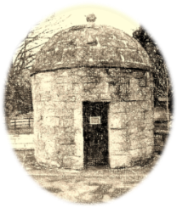
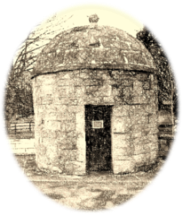
Can We Help?

We are writing in conjunction with Shrewton Parish Council.

We know the current situation is hitting lots of people hard and we are actively recruiting a range of volunteers with different skill sets to offer the right support in the right places. We are also working with the Council and local GP surgeries to be able to help with prescriptions, shopping and phone support contact.

But maybe you already know that you may need some support yourself, if so please let us know now so we can begin to work out a plan with you.

Even if you don’t need help now would you please return this slip to us so that we will know if you are either currently in one of the vulnerable groups or live with someone who is. Once your form is complete, you can return it:
- Through the door of The Rectory, Chapel Lane, Shrewton
- by email to us at reveleanorrance@gmail.com
- Or you can call and request a pick up on 01980 620580
We’d be grateful if you could get back to us as soon as possible so we can begin to get our support network in place.
Name(s)
Street Address
Contact number
Email (if applicable)
I can hear well enough to use the phone
I use the computer and happy to use email
I would prefer contact via leaflets / letters
I confirm I am happy for my details to be stored for this purpose
Can We Help?

We are writing in conjunction with Shrewton Parish Council.

We know the current situation is hitting lots of people hard and we are actively recruiting a range of volunteers with different skill sets to offer the right support in the right places. We are also working with the Council and local GP surgeries to be able to help with prescriptions, shopping and phone support contact.

But maybe you already know that you may need some support yourself, if so please let us know now so we can begin to work out a plan with you.

Even if you don’t need help now would you please return this slip to us so that we will know if you are either currently in one of the vulnerable groups or live with someone who is. Once your form is complete, you can return it:
- Through the door of The Rectory, Chapel Lane, Shrewton
- by email to us at reveleanorrance@gmail.com
- Or you can call and request a pick up on 01980 620580
We’d be grateful if you could get back to us as soon as possible so we can begin to get our support network in place.
Name(s)
Street Address
Contact number
Email (if applicable)
I can hear well enough to use the phone
I use the computer and happy to use email
I would prefer contact via leaflets / letters
I confirm I am happy for my details to be stored for this purpose

