## The Orchard Partnership



Child Confidential Medical Registration Form

## Drs HL Meader, LM Macready, JM Banfield, HV Pickup, AR Corke, HRL Bond, SJ Butcher and L Kinlin

Please complete all pages in full using block capitals and in black ink

First Names (in full): _________________________ Surname: __________________________________

Previous Surnames: _________________________ Date of birth:_____/______/_______

🞏 Male 🞏 Female NHS Number: _______________________________

Town & country of Birth: ________________________________________________________________________

Current address: ___________________________________________________________________________

____________________________________________________________________________________________

Postcode: ________________________ Email address: ___________________________________________

Landline number: __________________________ Mobile number: __________________________________

Please help us trace your child’s previous medical records by providing the following information:

Your previous address in UK: ________________________________________________________________

____________________________________________________ Postcode: ___________________________

Name of previous Doctor surgery while at that address: ____________________________________________

Address of previous Doctor: __________________________________________________________________

_________________________________________________________________________________________

Where did your child last receive treatment? Eg *GP, Walk in Centre, MIU, Emergency Department etc*

*________________________________________________ Date of visit: ___________________________________*

If you are from abroad:

Your first UK address where registered with a GP: ____________________________________________________

____________________________________________________________________________________________

If previously resident in UK date of leaving: __________________Date you first came to UK: _________________

Your Data Matters to the NHS - Information about your health and care helps us to improve your individual care, speed up diagnosis, plan your local services and research new treatments. The NHS is committed to keeping patient information safe and always being clear about how it is used. How your data is used - Information about your individual care such as treatment and diagnoses is collected about you whenever you use health and care services. It is also used to help us and other organisations for research and planning such as research into new treatments, deciding where to put GP clinics and planning for the number of doctors and nurses in your local hospital. It is only used in this way when there is a clear legal basis to use the information to help improve health and care for you, your family and future generations.

Wherever possible we try to use data that does not identify you, but sometimes it is necessary to use your confidential patient information. If you are happy for your confidential patient information to be used for research and planning, you do not need to do anything. To find out more about the benefits of data sharing, how data is protected, or to make/change your opt-out choice visit [www.nhs.uk/your-nhs-data-matters](http://www.nhs.uk/your-nhs-data-matters)

Do you cosnent to your GP health record being made available to other NHS care services that Care for you?

🞏 Yes (recommended) 🞏 No, never

Do you consent to your GP Practice viewing your health record from other services that care for you?

🞏 Yes (recommended) 🞏 No, never

If you need your doctor to dispense medicines & appliances:

For Dispensing Practices only:

* I live more than 1 mile in a straight line from the nearest chemist

If you are not a dispensing patient please specify which chemist you would ike to collect your medication from:

Name of chemist: ________________________________________ Town: ______________________________

Please Tell Us About Yourself:

Are you a carer ? Yes No

Personal Medical History

Type of birth (eg.normal, forceps, caesarean if under 5) _____________________________________________

Birth weigh (if under 5) ______________________________ Feeding if under 5 : Breast/ Bottle/Both

Has your child ever suffered from any important medical illness, operation or admission to hospital?

If so please enter details below:

Condition Year diagnosed Ongoing

1. ______________________________ ___________________ Yes / No

2. ______________________________ ___________________ Yes / No

3. ______________________________ ___________________ Yes / No

Family history

Have any close relatives (*father, mother, sister, brother only*) ever suffered from any of the following:

(please indicate who in the boxes)

|  |  |  |  |  |  |  |
| --- | --- | --- | --- | --- | --- | --- |
| Heart attack | Stroke | Diabetes | High blood pressure | Asthma | Glaucoma | Cancer |
|  |  |  |  |  |  |  |

Immunisations

|  |  |  |  |
| --- | --- | --- | --- |
| Immunsation | Year | Immunisation | Year |
| Tetanus |  | Polio |  |
| Typhoid |  | Yellow Fever |  |
| Hepatitis A |  | HiB |  |
| Whooping cough |  | Measles |  |
| MMR |  | BCG (TB) |  |
| Meningitis |  |  |  |
| Booster: Tetanus |  | Booster: MMR |  |
| Booster: Diphtheria |  | Booster: Polio |  |

Please list any allergies your child has to any drugs/medication/substances eg. latex

Name of medication What was the problem or upset?

1. ________________________________ ____________________________________
2. ________________________________ ____________________________________
3. ________________________________ ____________________________________

List of current medication - if you have a copy of repeat medication, please pass to reception to copy

Name of medication Dosage

1. ________________________________ ____________________________________
2. ________________________________ ____________________________________
3. ________________________________ ____________________________________

Ethnicity

Please indicate your ethnic origin:

🞏 British or mixed British 🞏 Irish 🞏 African 🞏 Caribbean 🞏 Indian 🞏 Pakistani

🞏 Bangladeshi 🞏 Chinese 🞏 Other (please state): _______________________________

🞏 Decline to state

Next of kin details to be held on your child’s file:

Their name: _______________________________________________________________________________

Contact number: _________________________________ Relationship to child: _________________________

I confirm that the information I have provided is true to the best of my knowledge

Signature: __________________________________ Date: ____________________________________

Signature of patient 🞏 Signature on behalf of patient 🞏

Summary Care Record

If you are registered with a GP practice in England you will already have a Summary Care Record (SCR), unless you have previously chosen not to have one. It will contain key information about the medicines you are taking, allergies you suffer from and any adverse reactions to medicines you have had in the past.

Information about your healthcare may not be routinely shared across different healthcare organisations and systems. You may need to be treated by health and care professionals that do not know your medical history. Essential details about your healthcare can be difficult to remember, particularly when you are unwell or have complex care needs.

Having a Summary Care Record can help by providing healthcare staff treating you with vital information from your health record. This will help the staff involved in your care make better and safer decisions about how best to treat you. Please visit <https://digital.nhs.uk/services/summary-care-records-scr> for further information.

You have a choice

You have the choice of what information you would like to share and with whom. Authorised healthcare staff can only view your SCR with your permission. The information shared will solely be used for the benefit of your care.

Your options are outlined below; please indicate your choice on the form overleaf.

1. Express consent for medication, allergies and adverse reactions only.You wish to share information about medication, allergies and adverse reactions only.
2. Express consent for medication, allergies, adverse reactions and additional information.You wish to share information about medication, allergies and adverse reactions and further medical information that includes: Your significant illnesses and health problems, operations and vaccinations you have had in the past, how you would like to be treated (such as where you would prefer to receive care), what support you might need and who should be contacted for more information about you.
3. Express dissent for Summary Care Record (opt out).Select this option, if you do notwant any information shared with other healthcare professionals involved in your care.

Please note that it is not compulsory for you to complete this consent form. If you choose not to complete this form, a Summary Care Record containing information about your medication, allergies and adverse reactions and additional further medical information will be created for you as described in point b) above.

You are free to change your decision at any time by informing your GP practice.

Summary Care Record Patient Consent Form

Having read the above information regarding your choices, please choose one of the options below:

Yes – I would like a Summary Care Record

□ Express consent for medication, allergies and adverse reactions only

**or**

□ Express consent for medication, allergies, adverse reactions and additional information

No – I would not like a Summary Care Record

□ Express dissent for Summary Care Record (opt out)

Signature _______________________________________________ Date: ______________________________

Communication declaration for children under 12 years

Where you have provided information and ticking the consent box below you are agreeing to The Orchard Partnership contacting you by text message, email or voicemail (using your landline number) for the purpose of appointment reminders, results, action needed following test results, referrals, health promotions, non NHS work, medication and Practice updates.

I acknowledge that text messages, emails and voicemails are an additional service and that they may not be sent on all occasions. The responsibility for attending appointments and cancelling them as well as contacting the Practice to obtain the results of recent tests still rests with me. I can cancel the text message and/or email facility at any time.

Text messages are generated using a secure facility but I understand that they are transmitted over a public network onto a personal telephone and as such may not be secure.

Emails and voicemail will also be generated using a secure facility but I understand that they are transmitted over a public network onto personal email accounts or landlines and as such may not be secure. We will only send the minimum amount of personal identifiable information needed to convey the message.

SMS and email is our preferred method of communication and will be used in the first instance, however, if you do not use/have a mobile telephone or email account, we may leave voicemails via your landline. Please note that voicemails are left only when the Practice must get in touch with you. It therefore is not available for appointment reminders or cancellations.

The parents/guardians of children aged 11 or under may use these services eg. to be reminded of children’s appointments. However, on the child’s 12th birthday, this service will be removed until the child turns 16 and personally completes a consent form.

|  |  |  |
| --- | --- | --- |
| Service | I agree to the use of (please tick) | I do not agree to the use of (please tick) |
| Text messaging |  |  |
| Emailing |  |  |
| Voicemail |  |  |

Details

Your name: _________________________________________________________

Your date of birth: _________________________________________________________

Relationship to child: _________________________________________________________

Mobile number: _________________________________________________________

Who’s number is this: 🖵 Mother 🖵 Father 🖵 Legal guardian

Email address ________________________________________________________

Who’s email is this: 🖵 Mother 🖵 Father 🖵 Legal guardian

Landline: _________________________________________________________

Signature: _________________________________________________________

For patients to complete who are not ordinarily resident in the UK

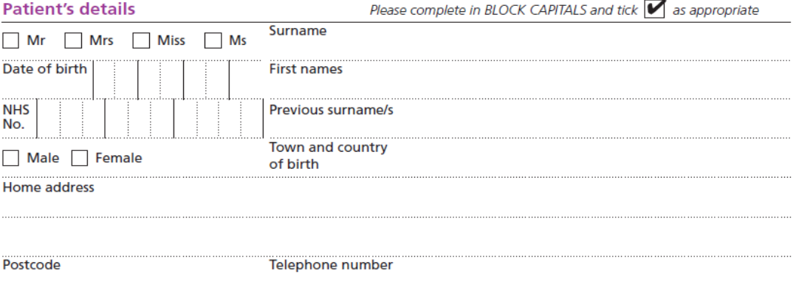



Office use: scan and send this page of form to: [NHSDigital-EHIC@nhs.net](mailto:NHSDigital-EHIC@nhs.net)